Ex.No. 12: NB-IoT vs LTE-M Throughput Simulation
AIM:
To simulate and compare the performance of NB-IoT and LTE-M communication technologies in terms of Throughput (Mbps), Latency (ms), and Packet Delivery Ratio (%) using MATLAB.
Objective:
- To evaluate and compare the Throughput (Mbps) performance of NB-IoT and LTE-M under varying network conditions.
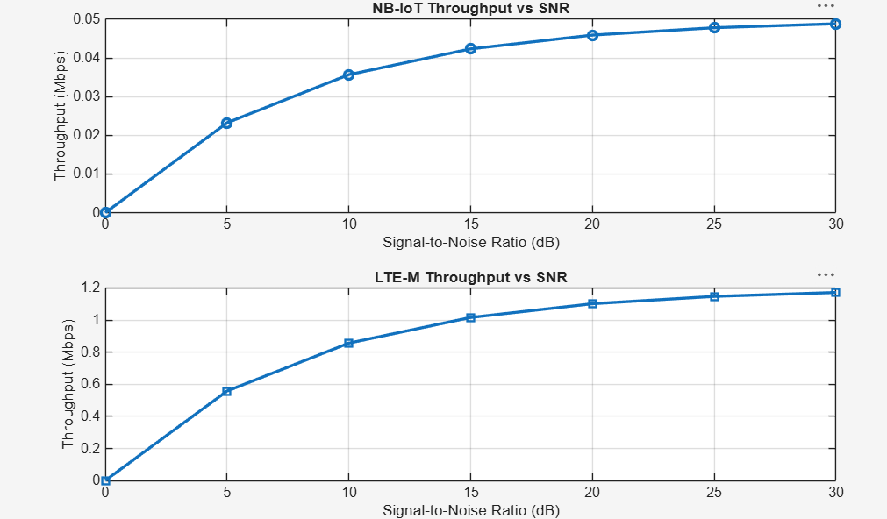
2.To analyze the Latency (ms) characteristics of NB-IoT and LTE-M and study their impact on real-time communication.
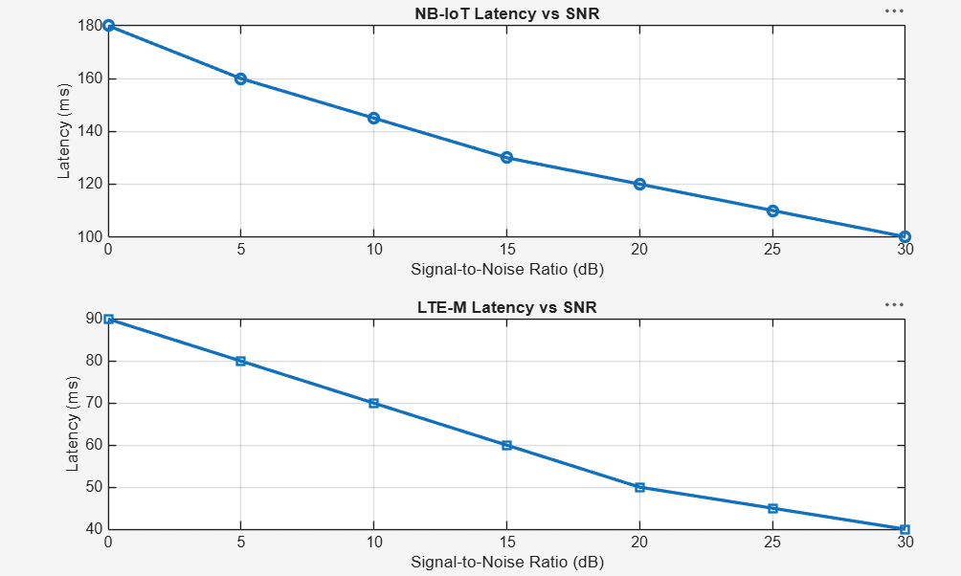
3.To measure and compare the Packet Delivery Ratio (%) of NB-IoT and LTE-M systems for reliability assessment.
